Name: _____________________________ Review of Trapezoids & Parallelograms

1.
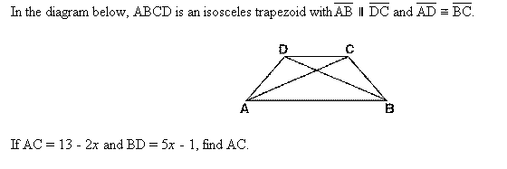
2.
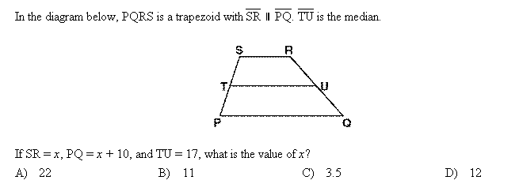

3. In the diagram below, LATE is an isosceles trapezoid with , , , and . Altitudes and are drawn. What is the length of ?
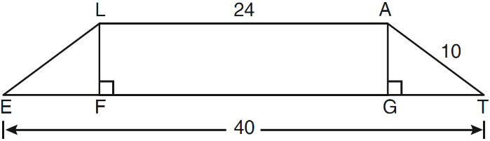

4. The accompanying diagram shows ramp leading to level platform , forming an angle of 45° with level ground. If platform measures 2 feet and is 6 feet above the ground, find the exact length of ramp
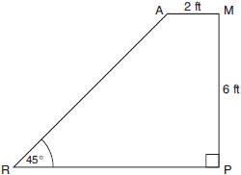
- Quadrilateral BATH has vertices B(1,-4), A(10,2), T(8,5), and H(2,1).
Use coordinate geometry to prove that quadrilateral BATH is a trapezoid but not an isosceles trapezoid.

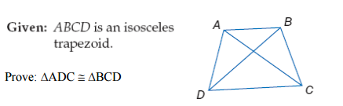
6.

7. In the accompanying diagram of parallelogram ABCD, and . Find the number of degrees in . Explain your reasoning.
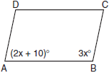

- In the diagram below of parallelogram ABCD with diagonals and , and . What is the measure of ? Explain your reasoning.
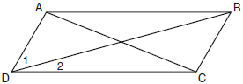

- In the diagram below of parallelogram STUV, , , and . What is the length of ? Explain your reasoning.
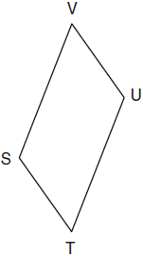

- As shown in the diagram below, the diagonals of parallelogram QRST intersect at E. If , , and , determine TE algebraically. Explain you reasoning.

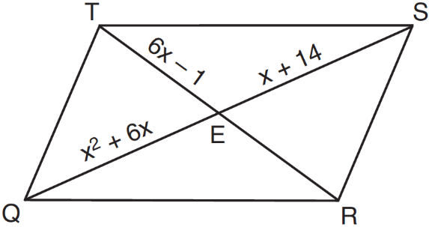

- The diagram below shows parallelogram LMNO with diagonal , , and Explain why is 40 degrees.

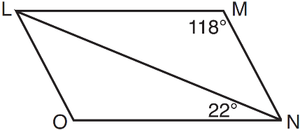

12.. In parallelogram QRST shown below, diagonal is drawn, U and V are points on and , respectively, and intersects at W. If , , and , what is ?

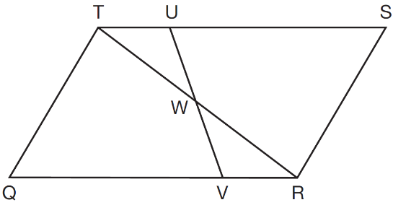

- In the accompanying diagram of parallelogram ABCD, diagonals and intersect at E, , and . What is the length of AC?

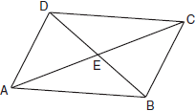

14. The measures of two consecutive angles of a parallelogram are in the ratio . What is the measure of an obtuse angle of the parallelogram? Explain your reasoning.

15. In the accompanying diagram of parallelogram ABCD, diagonals and intersect at E, 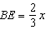, and What is the value of x?

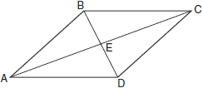

16.. Use the accompanying diagram and coordinate geometry to prove the quadrilateral is a parallelogram.
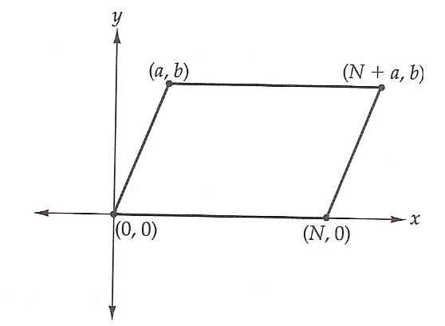

17.
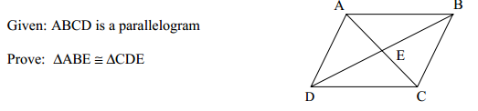
17.

18.
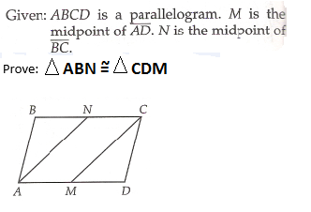

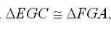
- Given: Parallelogram ABCD,
Prove:

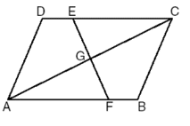

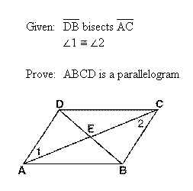
20.

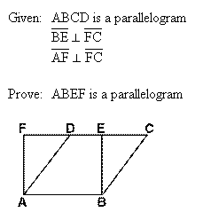
7.

